Chapter 12, Solution 10.

For the circuit in Fig. 12.43, determine the current in the neutral line.

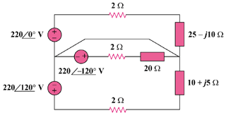

440∠0˚ V

440∠120˚ V

440∠–120˚ V

Figure 12.43
For Probs. 12.10 and 12.58.

Solution

Since the neutral line is present, we can solve this problem on a per-phase basis.

For phase a,

For phase b,

For phase c,

The current in the neutral line is

or

21.56∠–89.96°A

